***HOTEL MANAGEMENT SYSTEM***

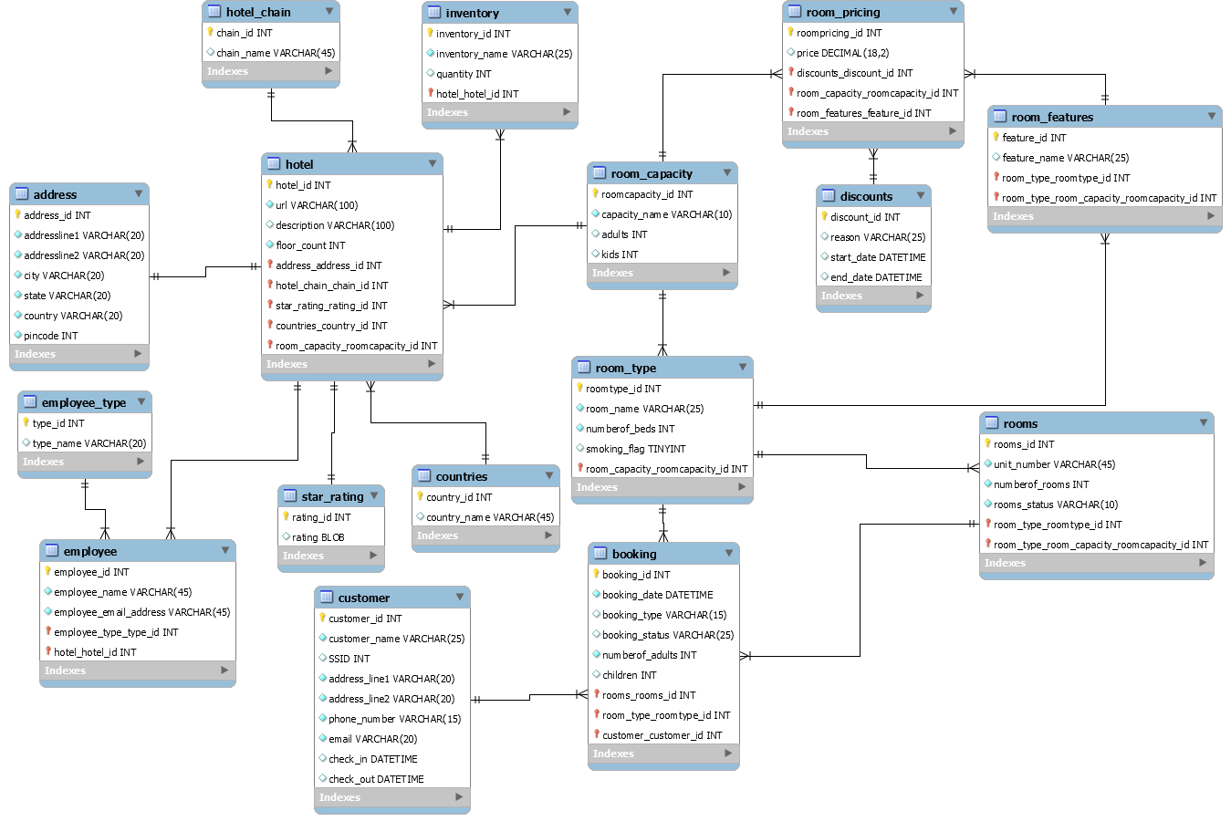

Enhanced Entity–Relationship

* Number of Tables: 16.
* Following are the names of the Tables:
* **countries**
* **room_features**
* **hotel_chain**
* **inventory**
* **star_rating**
* **address**
* **discounts**
* **hotel**
* **room_capacity**
* **booking**
* **room_pricing**
* **rooms**
* **employee_type**
* **customer**
* **room_type**
* **employee**

|  |  |  |
| --- | --- | --- |
| TABLE NAME | PRIMARY KEY | FOREIGN KEY(S) |
| countries | country_id | --- |
| room_features | feature_id | --- |
| hotel_chain | chain_id | --- |
| inventory | inventory_id | hotel_hotelid |
| star_rating | rating_id | --- |
| address | address_id | --- |
| discounts | discount_id | --- |
| hotel | hotel_id | country_countryid, room_capacity_roomcapacity_id, address_address_id, star_rating_rating_id, hotel_chain_chain_id |
| room_capacity | roomcapacity_id | --- |
| booking | booking_id | customer_customer_id, rooms_rooms_id,  room_type_roomtype_id |
| room_pricing | roompricing_id | discounts_discount_id, room_capacity_roomcapacity_id, room_features_feature_id |
| rooms | room_id | Room_type_roomtype_id, room_type_room_capacity_roomcapacity_id |
| employee_type | type_id | --- |
| customer | customer_id | --- |
| room_type | roomtype_id | room_capacity_roomcapacity_id |
| employee | employee_id | employee_type_type_id, hotel_hotel_id |

**Each table attributes explanation:**

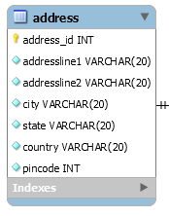

**Address:** Used to store address details

**Address_ID:** used to represent unique hotel address

**AddressLine1:** used to store address line1

**AddressLine2:** used to store address line2

**City:** used to store city

**State:** used to store state

**Country:** used to store country

**PinCode:** used to store pin code details

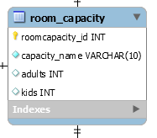

**Room_Capacity Table:** It is used to store room capacity details

**RoomCapacity_ID:** Used to store unique of room capacity information

**Capacity_Name:** Used to store total capacity details

**Adults:** Used to store number of adults in room

**Kids:** Used to store number of kids in room

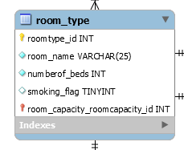

**Room_Type:** It is used to store room category details

**RoomType_ID:** It is unique representation of room type

**Room_Name:** Used to store room name

**NumberOf_Beds:** Used to store total beds in rooms

**Smoking_Flag:** Used to store smoking allow in that room or not

**Room_capacity_roomcapacity_ID:** used to represent capacity details. It is related with RoomCapacity table.

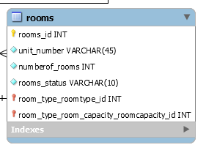

**Rooms:** Used to store rooms information

**Rooms_Id:** Used to represent unique id of room

**Unit_Number:** Used to store room door number

**NumberOf_Rooms:** Used to store total rooms inside room

**Room_Status:** Used to store room status like booked or not

**Room_type_roomtype_ID:** Used to represent room type. It is related with RoomType.

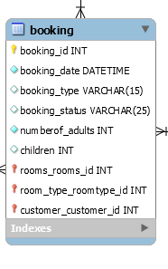

**Booking:** Used to store hotel booking information

**Booking_ID:** used to represent unique booking

**Customer_customer_ID:** used to store booked customer details. It is related with Customer table

**Booking_Date:** used to store booking start date

**Booking_Type:** used to store booking end date

**Booking_Status:** used to store booking status

**Rooms_rooms_Id:** used to represent booked room. It is related with Room table

**Room_Type_roomtype_ID:** used to represent booked room type. It is related with RoomType table

**NUmberOf_Adults:** used to store total adults in booking

**Children:** used to store total kids in booking.

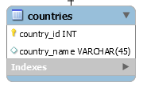

**Countries Table**: It is used to store countries information

**Country_ID:** It is unique representation of country

**Country_Name:** It is used to store country name

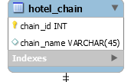

**HotelChain Table:** It is used to store hotel chain information

**Chain_ID:** It is used to store hotel chain unique id

**Chain_Name:** It is used to store Hotel Chain Name

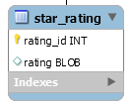

**Start_Rating Table:** It is used to store rating information

**Rating_ID:** It is unique representation of rating id

**Rating:** It is used to store rating image

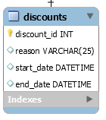

**Discounts Table:** It is used to store Discount information

**Discount_ID: It** is unique representation of discounts

**Reason:** Used to store discount reason information

**Start_Date:** It is used to store discount start date

**End_Date:** It is used to store discount end date

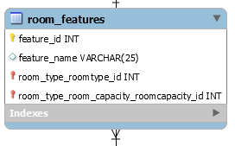

**Room_Features:** Used to store hotel rooms facility details

**Feature_ID:** Used to representation unique id of feature

**Feature_Name:** used to store facility name, description.

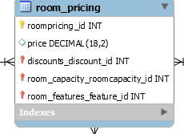

**Room_Pricing:** It is used to store room prices details

**RoomPrice_ID:** Used to unique representation of room price

**Price:** used to store room price

**Discount_discount_Id:** used to represent discount of that room. It is related with discount table

**Room_capacity_roomcapacity_ID:** used to represent capacity details. It is related with RoomCapacity table

**Room_features_feature_id:** Used to represent features details. It is related with Features table

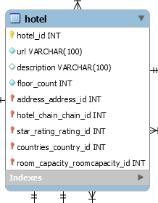

**hotel:** used to store hotel information

**hotel_id:** used to represent unique hotel

**countries_country_id:** used to represent hotel located in country. It is related with country table

**hotel_chain_chain_id:** used to store hotel chain details. It is related with HotelChain table

**URL:** used to store hotel url

**description:** used to store more hotel details

**floor_count:** used to store total floors in hotel

**star_rating_rating_id:** used to represent ration of hotel. It is related with Rating table

**room_capacity_roomcapcity_ID:** used to represent room capacity in hotel. It is related with RoomCapacity table

**address_address_ID:** It used to represent hotel address. It is related with Address table

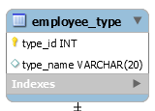

**Employee_Type:** Used to store hotel employees details

**Type_ID:** used to represent unique employee type id

**Type_Name:** used to store employee category

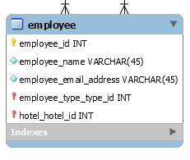

**Employee:** Used to store employees details

**Employee_ID:** used to represent unique employee id

**Hotel_hotel_ID:** used to store employee working in hotel. It is related with Hotel table

**Employee_Name:** used to store employee name

**Employee_type_Type_ID:** used to represent employee type. It is related with EmployeeType table

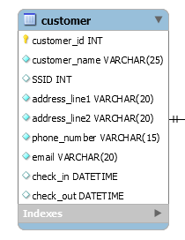

**Customer:** Used to store customer details

**Customer_ID:** used to represent unique customer id

**Customer_Name:** used to store customer name

**SSID:** used to store customer unique id in hotel

**Address_Line1:** used to store customer address line1

**Address_Line2:** used to store customer address line2

**Phone_Number:** used to store customer phone number

**Email:** used to store customer email

**Check_In:** used to store customer check in date

**Check_Out:** used to store customer check out date

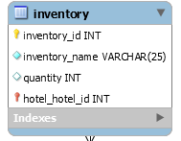

**Inventory:** used to store hotel inventory details

**Inventory_ID:** used to represent unique of inventory

**Inventory_Name:** used to store inventory name

**Hotel_hotel_ID:** used to reperesnt inventory of hotel. It is related with Hotel table

**Quantity:** used to store total inventory of hotel**.**